**Introduction on Unit Templates** (Speaker: Mrs. Debbie Liberi, District Coordinator, CEEMS, UC;June 23, 2015**,** 1:00 pm–2:45 pm)

This session was presented by Ms. Debbie Liberi on Tuesday June 23, 2015 from 1:00 to 2:30 at the UC in Zimmer Hall. The PD was designed for an audience of both RET and CEEMS in-service teachers from the Cincinnati tristate area.

Ms. Liberi began the session by introducing Dr. Kukreti, the principal investigator for CEEMS and RET to the group and he took the opportunity to welcome everyone. Ms. Liberi continued to lay out the major working parts of the CEEMS and RET programs outlining the overriding goals of educational research at UC. Ms. Liberi serves as the District Coordinator for the CEEMS program and the Program Coordinator for RET. Her vast educational experiences make her the perfect fit for coordinating both programs. She holds degrees in Biology and Education, and has applied them to over 30 years of practical teaching experience in the Cincinnati Public School District. She continues to engage in a variety of roles through UC and CPS as a way to mentor in-service teachers. See **Figure 1** below. At the conclusion of the introduction, Ms. Liberi had all participants subscribe to Poll Everywhere as a means to formatively assess the knowledge gained during the day’s instruction.

The general focus of the workshop was to familiarize all project participants with the CEEMS instructional unit template, see **Figure 2** below. This template will be used by both the RET and CEEMS teachers as they build and publish units to be used in classrooms across the tristate area. The unit template and wiki publishing is a way of actively creating a data base of materials for math and science teachers to implement in their classrooms.

|  |  |
| --- | --- |
| **Figure 1: Introduction by Debbie Liberi** | **Figure 2: Template Overview** |

Within explaining the unit template, Debbie Liberi provided insight as to how the EDP fits into and drives the student learning of a CEEMS unit. PD participants engaged in activities that highlighted the importance of incorporating both EDP and CBL into daily classroom instruction. The activities gave participants the chance to practice the skill of imbedding EDP/CBL into instructional units. Examples were given and reviewed that can be used as a guide toward building future instructional units.

The second half of the workshop was dedicated to looking at specific parts of the template and identifying the critical components to implementing a successful unit (see **Figure 3** on next page). The difference between activities and lessons was identified and the structure of the components was investigated. The participants learned how to embed formative and summative assessments into unit locations that make sense regarding the flow of instruction. CEEMS/RET students were also reminded that school and state standards should play a significant role in unit design. The goal is not to create fun engaging lessons that have little educational value, but to use the CBL and EDP as a way to engaging students in learning about the parts of the world that they care about. The session contained extensive discussion on how to steer students to a predetermined challenge that the students feel connected too. Upon the conclusion of the PD, program participants are now able to begin significant work toward constructing the unit deliverables for each program. In closing Debbie offered any additional assistance should there be questions about using the template to build a CEEMS unit.

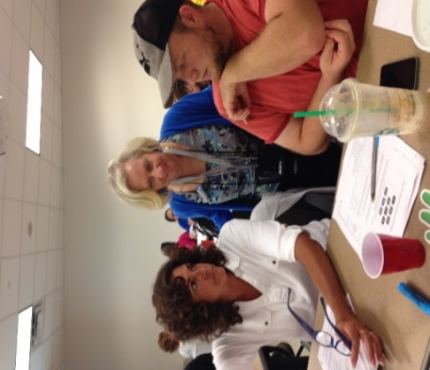

**Figure 3 Identifying Key Components**